Student Name:
Marcus Wilson

English Language Arts 10-1
Unit 3:
Romeo and Juliet by William Shakespeare

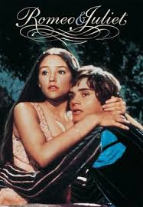

Sherwood Park: 464-1899 Fort Saskatchewan: 992-0101 Vegreville: 632-7998
Formative Assessment
These are assignments in which you practice what you are required to know, and be able to do. These assignments are important in your learning process.

Summative Assessment
When you have completed the work in this booklet you are required to complete two summative assessments which will become part of your final grade. Assessment #1 is a comprehension test - do make sure to review the terminology and the figurative language from this unit. Assessment #2 is a take-home essay - see the end of this unit for information regarding the essay topics.

In your Moodle course you will have a link to the original and a translated text, an audio recording, a film, and a short, animated video.

1. Introduction to Shakespeare

Chances are that even if you are not familiar with any of William Shakespeare’s plays, you will still have heard of the famous love story of two star-crossed lovers - Romeo and Juliet! In fact, there are few people in the English-speaking world who haven’t heard about this famous love story. Not only has Romeo and Juliet been depicted in movies, ballets, operas, and ice dancing, many contemporary stories have borrowed the plot, characters, and themes of this famous play.

- Let’s begin . . .

- What does the phrase,“tragic love” mean to you? Give an example of “tragic love” from stories, movies, or television shows.
I believe it means when love goes badly. Some examples of tragic love stories are The Notebook, West Side Story and The Titanic.

- Define “tragedy” in your own words and give an example from real life (for example, from the news, your life, or someone you know)
A tragedy is something really sad that happens. A tragedy in my life is when 4 people very important to me died within a span of 3 years.

- Do you think that the story of Romeo and Juliet is important to your life as a teenager? Why or why not?
No I do not think it’s important to me, love is not a part of my life at the moment.

- Time for some Research: your task is to find three stories (not a trilogy), or movies, whose plot has been based off the story of Romeo and Juliet. Provide a brief description of each.
Warm Bodies: At a scavenger party, R, a zombie, meets Julie and feels strangely protective of her. As he begins to regain his human tendencies, their love is threatened by the very difference of their existence.

West Side STory: Lovers Maria and Tony find themselves entangled in the bitter battle between their gangster families. Knowing this feud will lead to disastrous consequences, Maria sends Tony to end the fight.
Underworld:Selene, a vampire warrior, is entrenched in a conflict between vampires and werewolves, while falling in love with Michael, a human who is sought by werewolves for unknown reasons.

b) What do we know about William Shakespeare?

Unfortunately, very little is known of the playwright, Shakespeare. Unlike today, where we have access to media that provides us with the latest up-to-date information on celebrities, very little was written about important people on the 16th century.
- We know that he was born in Stratford-upon-Avon, England, and was baptized in the Holy Trinity Church in April 23, 1564.
- His father, John, was a glove maker and a local government official, and his mother, Mary, was the daughter of a wealthy landowner.
- We also know that shakespeare attended the local grammar school where he would have received a very good education in Latin and the Classics.
- We do know that he could not have attended university as, only single men could attend and, as Shakespeare at the age of 18 had married Anne Hathaway (a woman eight years his senior), he would not have been eligible.
- Anne and Shakespeare had three children: Susanna, and twins Judith and Hamnet.
- Shakespeare died on April 23, 1616, and is buried in the Holy Trinity Church in Stratford.

c) The Lost Years:

The years from 1585 - 1592 are referred to as Shakespeare’s “lost years” as we know nothing of his activities during this time. However, in 1592 we know that he had established himself as a playwright in London, which implies that he had likely been working as an actor before he started to write plays.

- Research: How many plays did Shakespeare write? What types of plays did he write?
He wrote 37 plays, they were comedies, histories, tragedies, and romances

- Besides plays, Shakespeare also wrote sonnets and narrative poems. What are the names of his two most famous narrative poems?
“Venus and Adonis” and “The Rape of Lucrece”

In 1613 Shakespeare left the stage in London and returned to Stratford. By this time he was a very wealthy man. In 1616, at the age of 52, Shakespeare died. He is buried beneath the stone floor of the Holy Trinity Church - the same church in which he was baptized.

Shakespeare’s gravestone bears an epitaph which he supposedly wrote himself.
It contains the following warning:

Good friend for Jesus sake forbeare,  To dig the dust enclosed here.  Blessed be the man that spares these stones,  And cursed be he that moves my bones. | 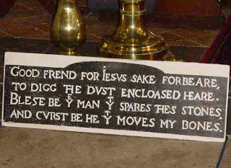
Needless to say, no one has ever moved his bones!

d) Please watch the following overview of The Globe Theatre
https://www.youtube.com/watch?v=m3VGa6Fp3zI

- Who were the “groundlings”?
They were the cheapest seats in the globe theatre, directly in front of the stage

- The roof was also known as:
Heaven

- What were the trapdoors used for?
It represents hell.

Did you know? Women were not allowed to perform on the stage; therefore, young boys, whose voices had not yet reached maturity, acted the female roles.

The Globe Theatre, which Shakespeare help to finance, opened in 1599. For the next 10 years, Shakespeare’s plays were performed there. In 1613, during a performance in Henry VIII, a theatrical cannon misfired and set fire to the wooden structure and thatched roof. The Globe Theatre burned down, however, there were no fatalities. It was re-built but, demolished in 1644 - 1645. In 1997, a new Globe Theatre was opened in Southwark (pronounced ‘Suthuk’) London, England. Today, visitors can visit it, or book to see a show in this wonderful theatre.

2. Shakespeare’s Language (it is not Old English!!)

Here are some sample texts that will show you how our English language has changed since 1066!

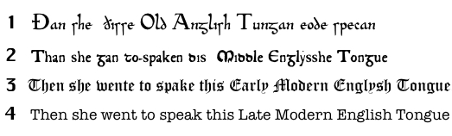 | 1.Old English  (Beowulf)  2.Middle English (Chaucer)  3.Elizabethan English (Shakespeare)  4.Modern English (today)

Shakespeare wrote during the latter part of the reign Queen Elizabeth I (b. 1533, d. 1603). This period is referred to as the ‘Elizabethan Era’. Many students feel very concerned when they know they have to read a Shakespearean play as some of the language sounds quite different from the language that we use today. In fact, some of the words are no longer in use in modern English.

Here are some words and phrases that you will encounter in Romeo and Juliet:

Shakespeare’s Words | Modern Meanings
Anon | Soon, right away
By my troth (rhymes with ‘oath’) | Truly, on my word
Coz (rhymes with ‘buzz’) | cousin
Fie (rhymes with ‘pie’) | An exclamation expressing disgust or anger
I trow (rhymes with ‘now’) | I think, I believe
Marry | An exclamation expressing surprise (really?) or anger at something that is unfair or mean (really!)
Sirrah | Sir, often used to imply anger or outrage
Good morrow | Good morning
Thee | You

Shakespeare frequently omitted letters from words to create a particular effect or sound. For example:

‘tis = It is |  | o’ = of |  | ta’en= taken
‘t = it |  | o’er = over
i’ = in |  | ne’er= never

Did you know? Many of the expressions that we use today were first used by Shakespeare. For instance:
- An eyesore
- Apple of her eye
- Dead as a doornail
- In my heart of hearts
- The long and the short of it
- What the dickens
- What’s done is done

Figurative Language

Shakespeare loved language and he loved to play with the language. As a result, his plays are rich with simile, metaphor, hyperbole, oxymoron and imagery - all of which would have delighted the audiences of his day as much as they do for today’s audiences, 400 years later! As we go through each Act, we will identify some of the figurative language used.

Simile: a comparison using like or as

Hyperbole: an exaggeration for dramatic effect.

Personification: attributing human qualities to something nonhuman.

Paradox: a statement that is seemingly contradictory or opposed to common sense and yet is perhaps true.

Metaphor: a comparison that doesn’t use the word like or as.

Oxymoron: a combination of contradictory words ex. cruel kindness.

- Now, see if you can correctly identify the following figurative language examples:

- I simply died of embarrassment.
Hyperbole

- The frisky puppy was as wiggly as an eel.
Simile

- The trees branches gently caressed the hiker.
Personification

- Jumbo shrimp.
Paradox

- Fair is foul, and foul is fair.
Oxymoron

- All the world’s a stage.
Metaphor

b) Structure of Shakespeare’s Dramas

Skim through your copy of Romeo and Juliet and look at how it is set up. You will notice the following structure:
- The play is divided into 5 Acts
- There are Scenes within each Act
- The lines in each Act are numbered

Each Act of a Shakespearean drama has a specific purpose:
- Act 1: establishes the setting, provides essential information, introduces the characters and their conflicts.
- Act 2: continues the action, introduces complications. Characters and their conflicts are fleshed out.
- Act 3: the major turning point, or climax in the action occurs
- Act 4: the action begins to “fall”, as do the fortunes of the protagonists. The falling action is usually set into motion by the crisis that arose in Act 3.
- Act 5: the final Act of a Shakespearean tragedy marks the tragic failure, and usually the deaths, of the protagonists. The tragic end occurs as a natural outgrowth of the action, the crisis, and the tragic flaws of the protagonists.

Climax: the moment in the plot when there is a definite, crucial change in direction and one becomes aware that the story is about to move toward its end. | Tragedy: in general, a literary work in which the protagonist meets an unhappy or disastrous end.
Protagonist: the central character or characters in a piece of literature. | Tragic Flaw: traditionally, the particular defect in a tragic hero that leads to his or her downfall

c) Shakespeare’s Verse

It was common practice in Shakespeare’s time to write in verse, even in plays. The majority of Romeo and Juliet is written in blank verse.
Blank verse: unrhymed iambic pentameter that has a regular rhythm | Iambic pentameter: is a regular rhythm pattern. Each line of verse consists of five groups - each group has a stressed and an unstressed syllable. It sounds like da DUM, da DUM, da DUM, da DUM, da DUM for example. “But, soft! What light through yonder window breaks.”
Rhyming Couplets: two rhymed lines of similar or identical metre that usually form a complete thought. | Sonnet: a 14-line poem with a regular rhythm (iambic pentameter) and a rhyme scheme. Shakespearean sonnets end with a rhyming couplet.

3. Time to begin reading Romeo and Juliet

Characters in Romeo and Juliet
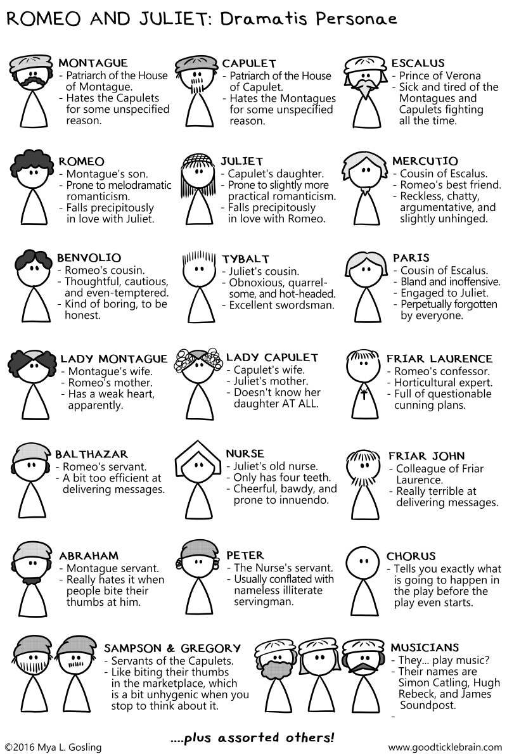
- Make sure to familiarize yourself with the characters before you begin.

** Shakespeare followed the pattern of ancient drama, where the prologue was a monologue recited by the Chorus. **
Prologue: an introduction recited by a Chorus. The purpose is to introduce the listener/reader to the necessary information required to understand the play. | Monologue: a long speech made by one person | Chorus: an actor in Elizabethan drama who recites the prologue to a play and from time to time comments on the action.
**Note: the Prologue is written in the form of a Sonnet.

- Act I, Prologue (Please watch)

Read the Prologue in your text while watching the following video: https://youtu.be/eSHW7a53K_8

Now, in your own words, explain what you have learned from the Prologue.
Two people are in love with each other, yet they aren’t allowed to be because their parents don’t like each other. It takes place in Verona.

Section 2: Begin reading the play - please follow along with the audio recordings below.
Act 1, Scene 1 gg
Audio Recording Act 1 Scene 1 Part 1
Audio Recording Act 1 Scene 1 Part 2
Audio Recording Act 1 Scene 1 Part 3

Sunday morning. Two of Capulet’s servants, Sampson and Gregory, have very little to do as they wander through the streets of Verona. They tease each other until they see two of the Montague’s servants; instantly, their good humour turns to anger. Fighting breaks out.

- What do we learn about the main characters from this scene? Complete the chart below.
Character | Trait | Evidence
Benvolio | 1. He’s a peacekeeper  2. He’s honest  3.He doesn’t like the girl | 1. Asks Tybalt to help him stop the fight  2.”Close fighting ere I did approach. I drew part to them. In the instant came”  3. “Be ruled by me, forget to think of her.” (L. 222)
Tybalt | 1. Desires conflict | - “What, drawn, and talk of peace? I hate the word.”
Romeo | 1. Dreamer  - He falls in love easily  - He doesn’t like conflict, he prefers love | 1. He has been behaving in an unusual way  2. Exaggerates the love and beauty of Rosaline.  3. “What fray was here?/Yet tell me not, for I have heard it all./Here’s much to do with hate, but more with love.” (l. 170)
Capulet | - He is loyal to Montague | 1. “Old Montague is come,/And flourishes his blade in spite of me.”
Montague | - Doesn’t like fighting | 1. Asks Benvolio, “Who set this ancient quarrel new abroach?” (l.130)  2. “Black and portentous must this humour prove/unless good counsel may cause remove.”

Figurative Language:

- Provide an example of an oxymoron from Act 1, Scene 1.
Cankered with peace, to part your cankered hate.

- Identify the following figure of speech:
“Love is a smoke raised the fume of sigh;/Being purged, a fire sparkling in lovers’ eyes;/Being vex’d, a sea nourish’d with lovers’ tears.
I think its a metaphor because there is no like or as

Listen to Act 1, Scenes 2 and 3 and follow along with the text.
Audio Recording Act 1 Scene 2
Audio Recording Act 1 Scene 3 Part 1
Audio Recording Act 1 Scene 3 Part 2
A masked ball is to be held by the house of Capulet.

- In your own words, give a brief summary of the two scenes that you have just read.
There is a fight between the Capulet and Monatgue houses and then Benivolo says he’ll help Romeo forget about Rosaline.

- In Scene 2, the Capulet servant invites Romeo and Benvolio to the masked ball. Why is this ironic?
Because the ball is to celebrate Paris’ plan to marry JUliet, ROmeo’s future love interest.

- Three important characters have been introduced in this scene. Identify them in the chart below. From what you have heard and seen so far, describe the personality of each.
Character | Personality Traits

Listen to Act 1, Scenes 4 and 5 and follow along with the text.
Audio Recording Act 1 Scene 4 Part 1
Audio Recording Act 1 Scene 4 Part 2
Audio Recording Act 1 Scene 5 Part 1
Audio Recording Act 1 Scene 5 Part 2
Audio Recording Act 1 Scene 5 Part 3

Benvolio and Mercutio persuade Romeo to join them at the ball. Juliet is there.

- How would you describe the friendship between Romeo and Mercutio? How do they act toward each other? What personality traits do they share?

- Romeo and Juliet have met and fallen in love. Do you believe it is possible to fall in love so quickly? Does physical attraction play a part? Has it ever happened to you?

Identify, and explain, the figurative language in the following:

- “When well-apparell’d April on the heel/of limping winter treads.” (1.2.27)

- “The earth hath swallow’d all my hopes but she.” (1.2.14)

- “Is love a tender thing? It is too rough,/too rude, too boisterous, and it pricks like a thorn.” (1.4.25-26)

- “My lips, two blushing pilgrims, ready stand/To smooth that rough touch with a tender kiss.” (1.5.95-96)

** Before you begin listening to Act 2, I would like to to take note of the fact that it, like Act 1, is introduced by the Chorus.**

Soliloquy: a speech given by a character alone on the stage - or, at least unheard by other characters - expressing his or her thoughts or feelings.

Shakespeare frequently wrote soliloquies for his main characters. They were meant to reveal exactly what was going on in those characters’ minds. He used them to reveal the deepest fears, feelings, and inner turmoil of the speakers.

Listen to Act 2, Scenes 1 and 2 and follow along with the text.
Audio Recording Act 2 Scene 1(no audio for this scene)
Audio Recording Act 2 Scene 2

Scene 2 is probably the most famous scene in the play. Even if people haven’t read Romeo and Juliet, most are familiar with the “balcony scene”. Romeo begins the scene with a soliloquy, declaring his love for Juliet without her actually listening. Not realizing that Romeo is in the courtyard, Juliet comes out onto the balcony and swears her never-ending love for him.

- List, in your own words, the statements that Romeo makes about Juliet in lines 2 - 23.

- Give an example of personification from lines 58 - 60.

- Give an example of hyperbole from lines 71 - 73.

- Who introduces the idea of marriage? Explain the plan.

Foreshadowing: when the author gives hints or clues about what’s going to happen.

- Even though Romeo and Juliet seem optimistic and joyful, foreshadowing in this scene suggests future difficulties for the couple. What obstacles stand in their way? Is their plan unrealistic, or might it work? Explain.

Listen to Act 2 Scenes 3 and 4 on Moodle and follow along with the text.

Audio Recording Act 2 Scene 3
Audio Recording Act 2 Scene 4 Part 1
Audio Recording Act 2 Scene 4 Part 2
In Scene 3 we are introduced to Friar Laurence (please note: Friar Laurence is their “spiritual” father, not their biological father!)

- Does Friar Laurence agree to perform the marriage? What are some of his concerns?

Scene 4 consists largely of comic relief and playing around with words. (puns)
- Who is referred to as “the prince of cats”? Why?

- Most of this scene is written in prose as opposed to blank verse. Why do you think Shakespeare made this choice?

- What do we learn about the wedding plans?

Listen to Act 2, Scenes 5 and 6 on Moodle and follow along with the text.

Audio Recording Act 2 Scene 5
Audio Recording Act 2 Scene 6

Scene 5 opens with Juliet speaking a soliloquy before she and the nurse talk about marriage plans. Scene 6 Friar Laurence urges Romeo and Juliet to be careful. He agrees to marry them.

- This scene begins with a soliloquy by Juliet. What do we learn about her character as she speaks?

- Throughout the scene, the nurse teases Juliet and refuses to be straightforward in her responses. What does this tell you about the nurse’s character?

- What does the expression, “Love is blind”, mean to you?

- In Act 1, Scene 5, line 135, Juliet’s comments foreshadow a tragic ending. In Act 2, Scene 6, line 7, Romeo states, “love-devouring Death do what he dare.” what does he mean? How are his words similar to Juliet’s?

Key Themes in Romeo and Juliet

Theme: is the controlling idea in a work of literature. It is not a summary of the main events of a story, nor does it teach a moral. It is generally a statement about human behaviour.
- Feuding Families
When the play opens, two of the principal families of Verona, the Montagues and the Capulets, are involved in an active, long-standing, feud. This feud is so severe that it extends beyond the two warring families and is destructive to much of Verona’s society.
- Choosing a marriage partner
Juliet finds herself in a difficult position because she has fallen in love with Romeo. However, Lord Capulet, Juliet’s father, has decided that he will choose a marriage partner for her.
- The impulsivity of youth
Romeo and Juliet are both very young. Because they’ve had few life experiences, they make impulsive moves rather than logically thinking things through.
- The role of fate in human affairs
The prologue uses the phrase “star-crossed lovers”, which implies that their love is doomed by the stars.

Listen to Act 3, Scene 1 on Moodle and follow along with the text.(Please note: this recording begins at line 137, therefore, please read lines 1 - 136 by yourself, then continue to follow along with the audio recording.)
Audio Recording Act 3 Scene 1

This scene begins with Mercutio “itching for a fight” and with Benvolio trying to persuade Mercutio to go home.

Act 3 is considered the climax of the play.

- What major event has happened to cause this to be the turning point in the play?

- Mercutio’s words, “A plague o’ both your houses”, point to one of the key themes of the play. Explain.

- “Ask for me tomorrow and you shall find me a grave man”, (3.1.97) is a pun. What is Mercutio’s double meaning in this phrase?

- Prince Escalus blames Romeo. Do you agree or disagree? Why?

Listen to Act 3, Scenes 2 and 3 on Moodle and follow along with the text.
Audio Recording Act 3 Scene 2 Part 1
Audio Recording Act 3 Scene 2 Part 2
Audio Recording Act 3 Scene 3 Part 1
Audio Recording Act 3 Scene 3 Part 2
Audio Recording Act 3 Scene 3 Part 3

Scene 2 begins with a long soliloquy from Juliet that is both passionate and romantic.
In her soliloquy, Juliet seems to have a premonition (a feeling of coming disaster), in lines 20 - 25, just as Romeo did before the Capulet party (1.4.106-111).
- Why does she choose to ignore such warning?

- Juliet weeps for her cousin as well as for her husband. Which grief has a bigger impact on her? Support your response with specific details.

Scene 3, Friar Laurence tells Romeo that his punishment shall be banishment, not death.
- Give one piece of evidence from the Friar, and one from the nurse, that show their impatience with Romeo’s “childish” behaviour.

- Write down as least three points that Friar Laurence uses in lines 108 - 158 to convince Romeo to “act like a man”.

Listen to Act 3, Scenes 4 and 5 on Moodle and follow along with the text.
Audio Recording Act 3 Scene 4
Audio Recording Act 3 Scene 4 Part 1
Audio Recording Act 3 Scene 4 Part 2
Audio Recording Act 3 Scene 4 Part 3

In Scene 4 there is a good example of dramatic irony (where we, the audience, know something that the characters are unaware of). Lord Capulet, believing that marriage will help Juliet “get over” her cousin’s death, promises Paris that he shall marry Juliet this week. However, they are unaware that, as they speak, Romeo and Juliet are upstairs in their marriage bed. Their ignorance of this important fact produces dramatic irony.

Scene 5
It’s now Tuesday morning. Romeo and Juliet have spent their wedding night together. Both know that Romeo must leave for Mantua immediately; however, the parting is painful. It doesn’t help that juliet has a terrible premonition in which she sees Romeo “Dead in the bottom of a tomb” (line 56)

- Give two examples of “night” imagery and two examples of “day” imagery from the speeches of Romeo and Juliet in lines 1 - 36.

- How does Juliet respond when she is informed of her upcoming marriage to Paris?

- In lines 127 - 139, Lord Capulet uses an extended metaphor in his speech to Juliet. What is the metaphor? What words or phrases extend it? Why is it effective?

Listen to Act 4, Scene 1 on Moodle and follow along with the text.
Audio Recording Act 4 Scene 1 Part 1
Audio Recording Act 4 Scene 1 Part 2

It is still Tuesday. Paris asks Friar Laurence to perform his and Juliet’s ceremony. Juliet enters.

There are many instances of dramatic irony in lines 1 - 43. Complete the chart to demonstrate your understanding of the dramatic irony.
The Apparent Situation  (what appears to be true) | What the Audience Knows  (the reality)
Paris believes that Juliet “weeps for Tybalt’s death” (l. 6)
Paris calls Juliet “my lady and my wife.” (l. 18)
Juliet to Paris, “[My face] is not mine own.” (l. 36)
Paris to Juliet and the Friar, “God shield I should disturb devotion.” (l. 41)

Listen to Act 4, Scenes 2 through 5 on Moodle and follow along with the text.
Audio Recording Act 4 Scene 2
Audio Recording Act 4 Scene 3
Audio Recording Act 4 Scene 4
Audio Recording Act 4 Scene 5 Part 1
Audio Recording Act 4 Scene 5 Part 2

The Capulet house where wedding preparations for juliet and Paris appear to be in full swing. After juliet apologizes to her father, he decides to move the wedding date forward to Wednesday.
Juliet goes to her room and convinces her mother and nurse to leave her alone.

In lines 84 - 90 of Scene 5, Capulet states, “All things … turn from their office … All things change them to the contrary.” complete the following chart to show which things have changed up to this point.
Changes in Romeo and Juliet
From: | To:
Romeo is distressed with Rosaline’s rejection of his love.
Romeo and Juliet are very happy together.
Nurse is supportive of Romeo and Juliet’s secret marriage.
Capulet is angry with his daughter.
 | A funeral is arranged for “dead” Juliet.

Select figures of speech that you found particularly effective in Act 4. Explain how each figure fits into the scene.

Figure of Speech | Example | Explanation
Simile
Metaphor
Personification

The Final Act:

Listen to Act 5, Scenes 1 through 3 on Moodle and follow along with the text.

Audio Recording Act 5 Scene 1 Part 1
Audio Recording Act 5 Scene 1 Part 2
Audio Recording Act 5 Scene 2
Audio Recording Act 5 Scene 3 Part 1
Audio Recording Act 5 Scene 3 Part 2
Audio Recording Act 5 Scene 3 Part 3
Audio Recording Act 5 Scene 3 Part 4
Audio Recording Act 5 Scene 3 Part 5

Every plan has the possibility of failure because of changing circumstances.

- How has fate worked against Romeo and Juliet is this final act?

- The Prologue refers to Romeo and Juliet as “star-cross’d”. How does the outbreak of the plague affect the “star cross’d lovers”?

- Shakespearean tragedies involve several deaths. Summarize the deaths that occurred in this play.

- Plays often end with some kind of satisfactory resolution. In this play, there may be the sense that order has been restored and peace has been re-established. How does Shakespeare bring about resolution in Romeo and Juliet? Are you satisfied? Explain.

FINIS

You have completed the formative work.

NOTE: There are two summative assessments for this unit:

- The Test
- The Project (Get the handout from your teacher)

